NOTES FOR V4 Board
- Buzzer volume trimmer option: If you don't want to have the ability to adjust the volume
of the buzzer, you can elect not to install the trimmer and instead install a wire jumper where "no trim" is marked on the board. Trimmer pads can accept long or square format trimmers.
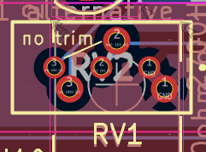
- Buzzer enable can be a 2-pin 2.54mm pin header with a jumper cap OR if you do not want the ability to disconnect the buzzer, can just be a jumper wire.
- Buzzer pads can accept buzzer with 6mm or 5mm connector spacing.
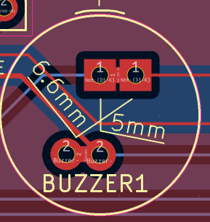
- D1/D2 is optional but is recommended to protect the transistor from inductive flyback from the buzzer. (install either D1 THT or D2 SMD)
- On-board reset button is optional but convenient to have.
- TCA9548A (I2C mux) cards are available with two different pin strip spacings. That is why there is a double row of pin pads on one side of the footprint. Use the set that fit your board if you are using the module instead of the SMD chip. If using the module version, it is recommended, but not mandatory, that you use a pin socket strip on the board instead of soldering the module directly to the board.
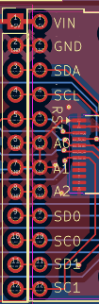

- All resistors, capacitors, diodes, and the transistor can be either SMD or THT components. Similarly, the TCA9548A may be a module or just the SMD chip. Use either the SMD component or the THT component for each part (not both). You can mix SMD and THT components on the board if you wish.
- It is recommended, but not mandatory, that you solder a pin socket strip to the board to plug in the Pro Micro rather than solder the Pro Micro directly to the board.

